Homework 3
Deadline: Monday 28/04/2014, 11:59 pm
Program description:
This program helps you in storing the large amount of data as a collection. The LinkedList is a part of collection that constructs a list containing the elements of the specified collection. Iterator methods returns the values in the order in which they are stored.
If you want to insert the data in the linkedListthen use add() method. The hasNext() method returns true if the iterator contains more elements and the next() method returns the next element in the iteration. To insert and remove the data at first, last and specified position in the linkedList, you use the addFirst(),addLast(), add(), removeFirst(), removeLast() andremove() methods. To retrieve the element with respect to a specified position use thegetFirst(), getLast() and get() methods.
Program output:
Based on the following output, generate your codes.
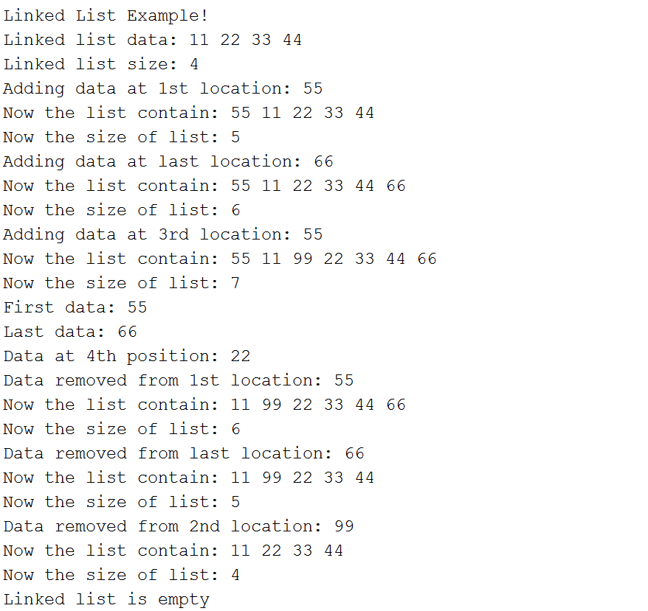
Program steps:
You can use these brief steps as a guideline, however, you can use any algorithm that will give the above output.
//Adding data in the list
//Create an iterator
//Check list empty or not
//Adding first
//Adding last or append
//Adding data at 3rd position
//Retrieve first data
//Retrieve last data
//Retrieve specific data
//Remove first
//After removing data
//Remove last
//After removing data
//Remove 2nd data
//After removing data
//Remove all
Note: this can all be done in one class, you do not need to create more classes.
[7 Marks]

